

Installation instructions
99-08 hayabusa generation 3 streetsmart system

MANUFACTURED EXCLUSIVELY FOR BROCK’S PERFORMANCE PRODUCTS BY HINDLE PRODUCTS LTD.
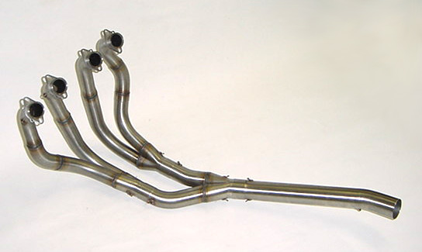
Note: These instructions-as well as additional details can be found at: www.brockracing.com

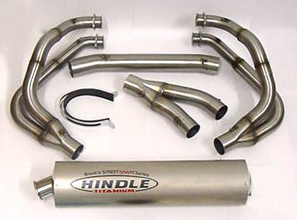

This package contains:

PN: S13-GEN3-FS (FRONT SECTION)
PN: S13-GEN3-Ti (TITANIUM MUFFLER)
OPTIONAL PN: S13-GEN3-C
(CARBON FIBER MUFFLER)

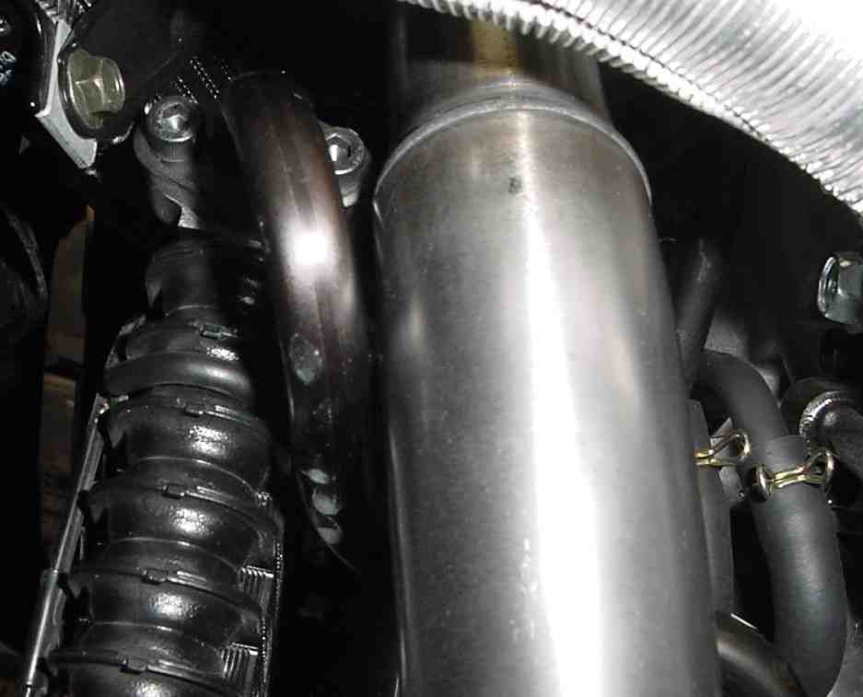
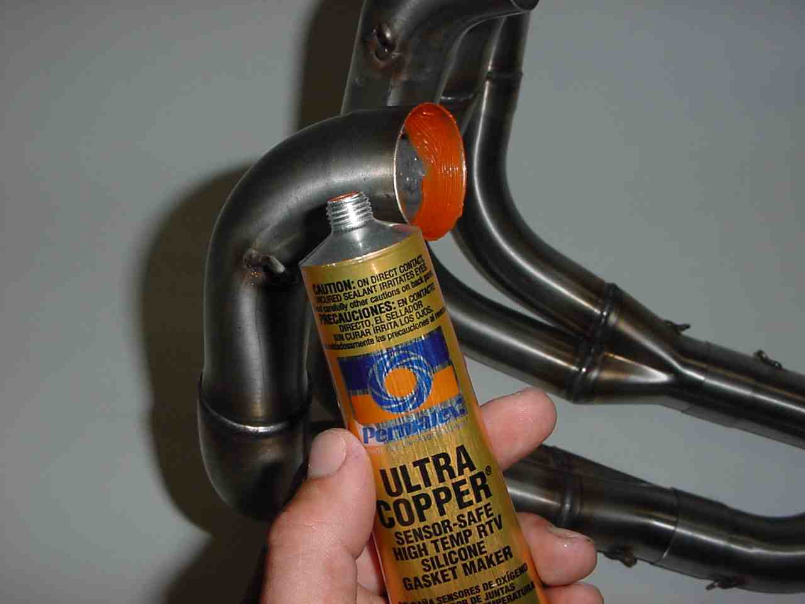

1: Pre-assemble system. Do not install springs. Note proper orientation of spigot spring mounting tabs when installed on engine. (We typically reuse the stock gaskets.)
Special Note: It is very important to pre-assemble the system! A slight twisting motion during assembly will allow the thin wall tubing to form-fit. Additionally, pre-assembly helps to detect any potential shipping damage.

3: Install system using Head Pipe springs with included spring tool. Check for adequate clearance between Pipe #1 and oil cooler line.
2: Apply a small amount of Permatex Ultra Copper to inside of Head Pipes.
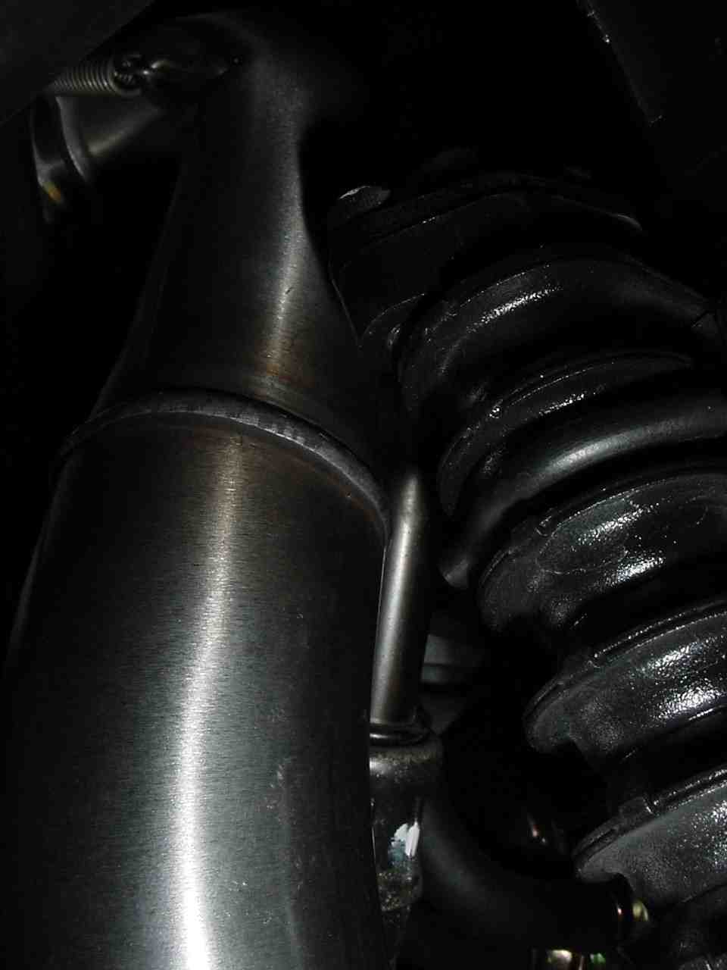
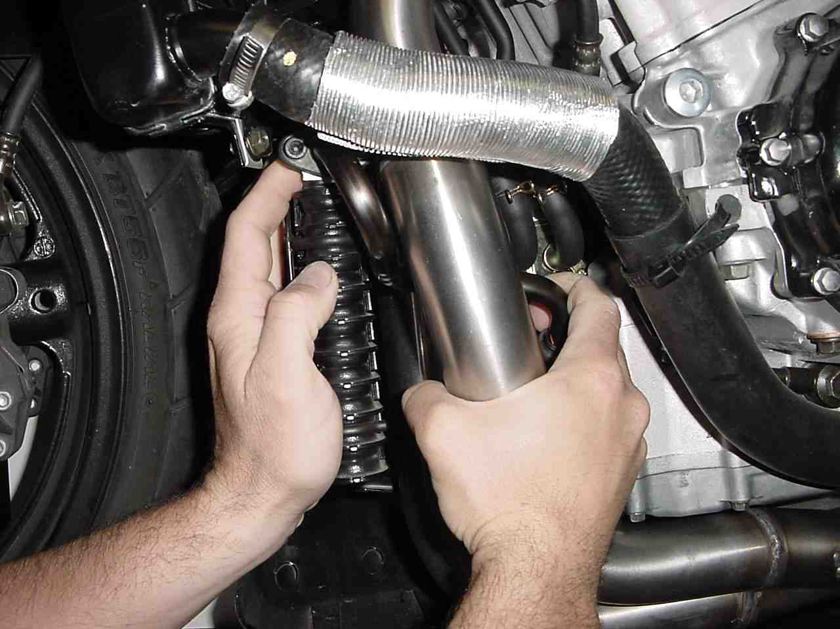

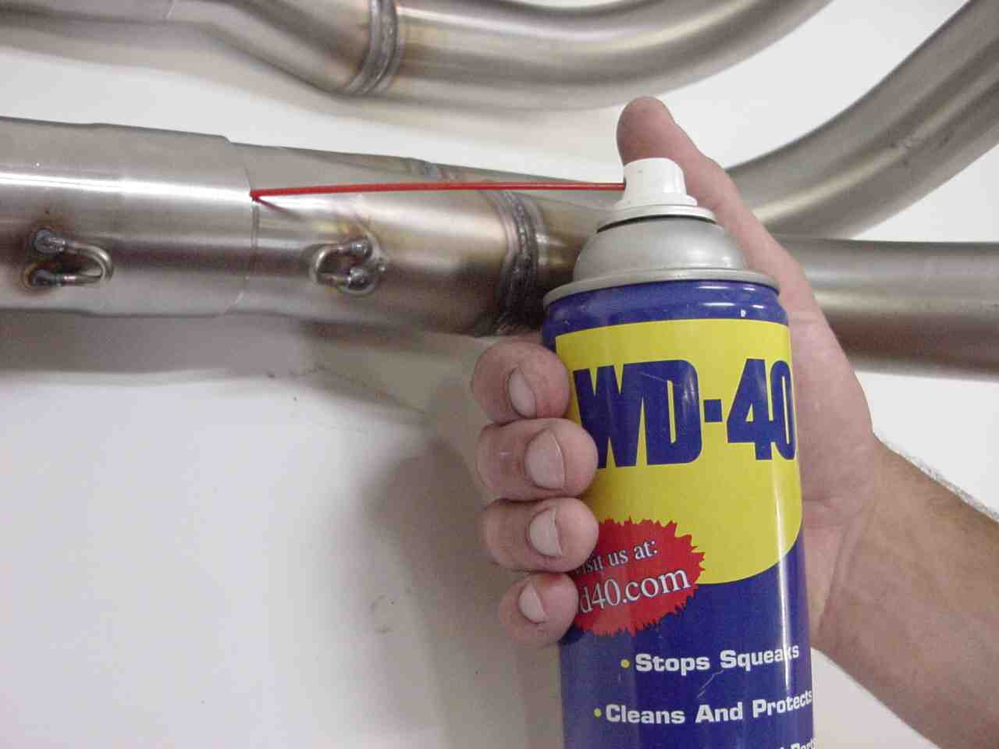

4: Adjust clearance, if necessary, by gently bending the tube away from the pipe. Use other hand to support the cooler. A minimal amount (1/16 Inch) of clearance is all that is required. DO NOT OVER BEND! SERIOUS DAMAGE TO THE COOLER LINE MAY RESULT.

5: Check clearance between Head Pipe # 4 and oil line. (If necessary, loosen oil line clamp bolts, adjust for additional clearance and re-tighten.)

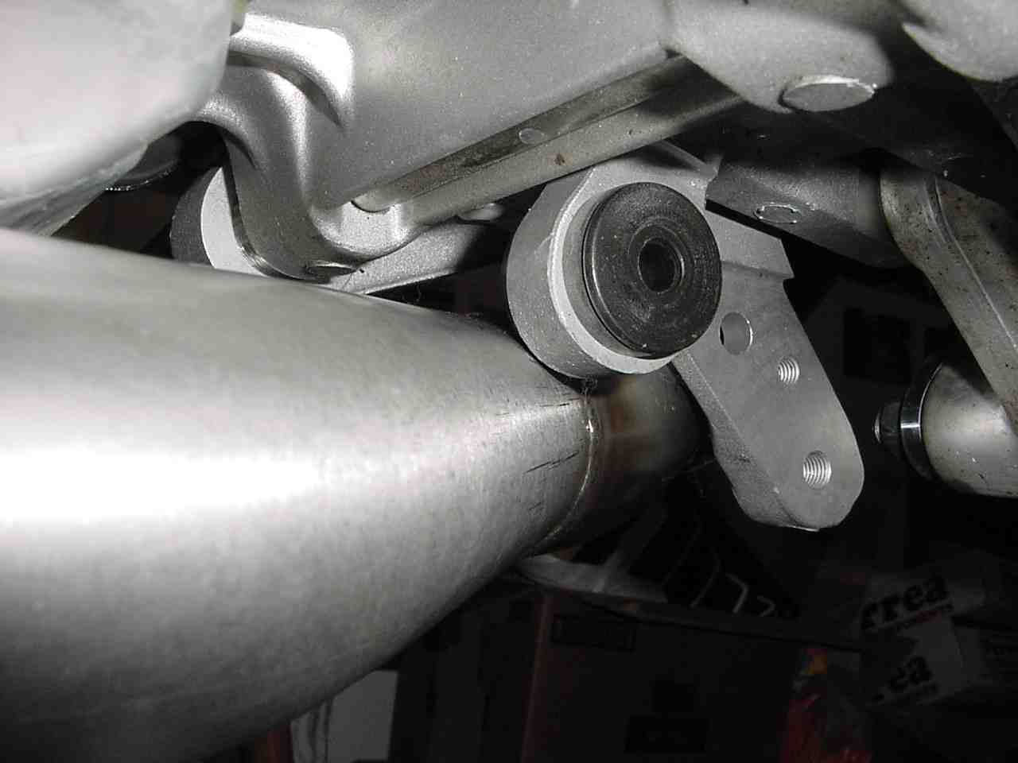
6: Check clearance between rear collector and stock system mounting tab.
7: Applying WD-40 to the pipe joints eases adjustment and/or disassembly.

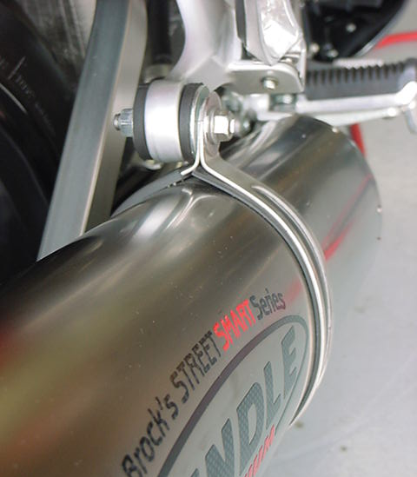

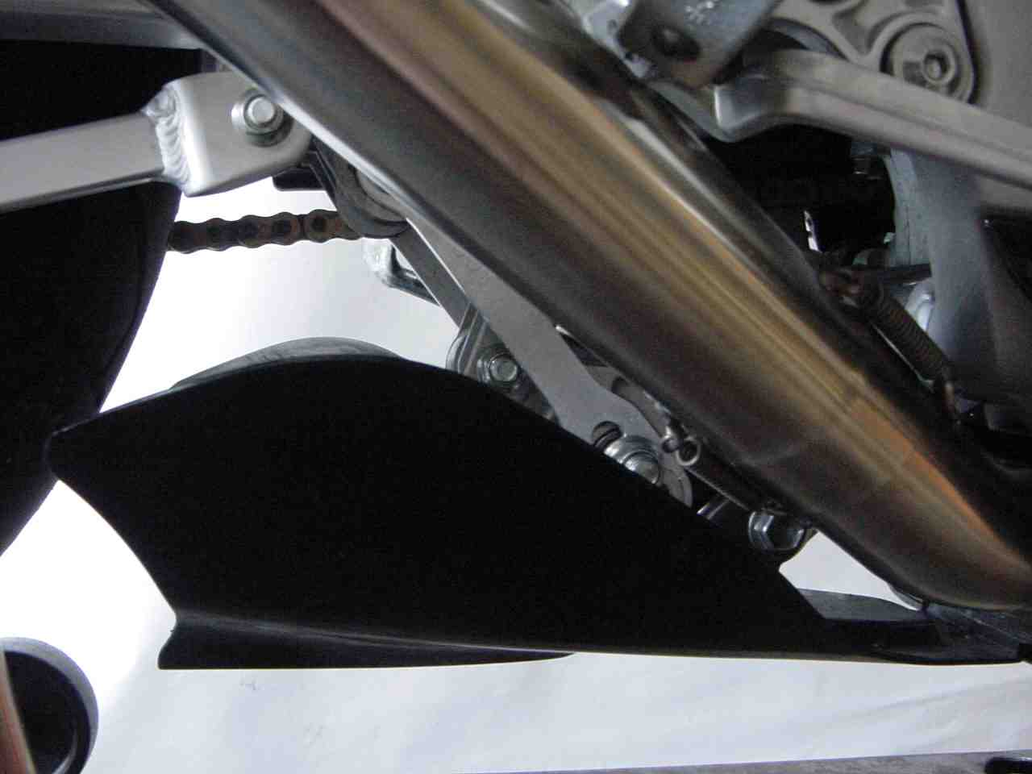

8: Rotate elbow pipe up until it nearly rests on the lower side of the foot peg. This assures maximum pipe to belly pan clearance, as shown.
9: Install all remaining springs. Mount Muffler with enclosed hanger assembly, on the outside of the stock bracket, using the stock mounting hardware.

Muffler Hanger and Strap: Are located in the long rectangular Muffler box under the taped flap marked “Open this end” or……on the opposite end of the box flap marked “Open other end”……

10. Clean system free of fingerprints with a soft cloth before starting engine.
11: Check for adequate clearance when installing bodywork.

WARNING: DO NOT START BIKE!
This system was designed to fit under stock bodywork with no modifications. The system will be very tight in the noted areas, but it does fit well when properly installed. No burning or damage to the bodywork will occur when the system is carefully installed and all areas are inspected for ¼ inch clearance minimum between the exhaust and body panels.

12. Install the appropriate BDE- Power Commander map for your application.
13. See enclosed Air Box Modification instructions. Maximum performance from your StreetSmart system can only be achieved with our suggested Box Modification and the proper map for your application.

Note: Pipe will turn a soft gold color. It is common for the pipe to smoke for a moment as the preservatives burn out of the stainless.

Please review Brock’s Performance Products policies and warranty information: http://prostores2.carrierzone.com/servlet/brockracing/Page?template=policy For Additional Information: Check our Information Forum at www.brockracing.com, e-mail advice@brockracing.com or call 937-912-0061.

